Participant Detail View
- Note multiple Participant Types. For participants with multiple roles, all roles will be mentioned. However only particular role detail view information will be shown (in this instance Referring Physician).
- Also note the Primary ID / Source and Other ID / Source are displayed.

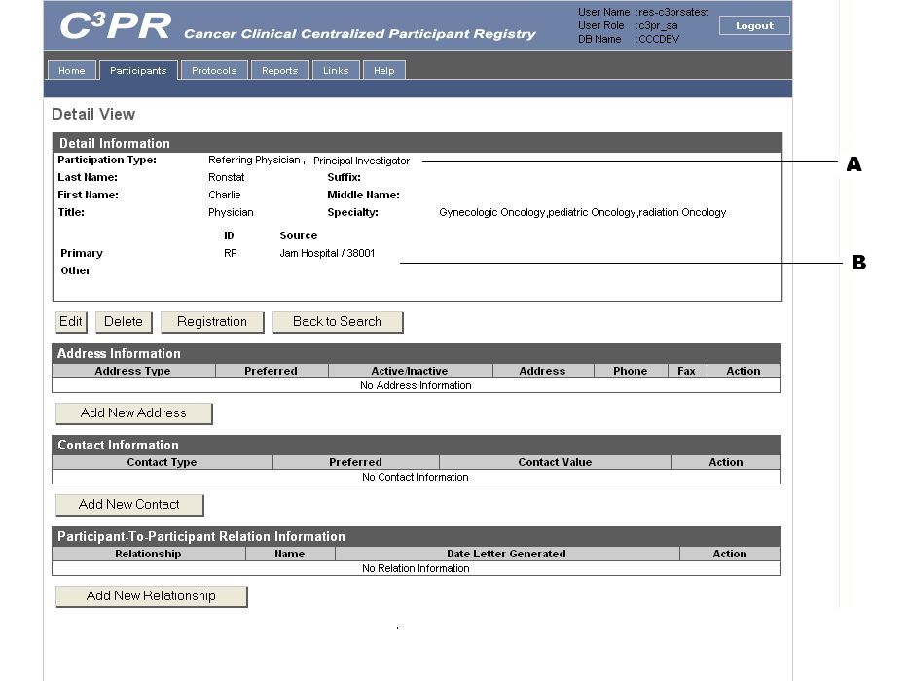

Participant Create
- Note the check boxes for Data Manager, Primary Investigator, Associated Investigator, Referring Physician, and Treating Physician.
- Also adding Primary ID / Source and Other ID / Sources.

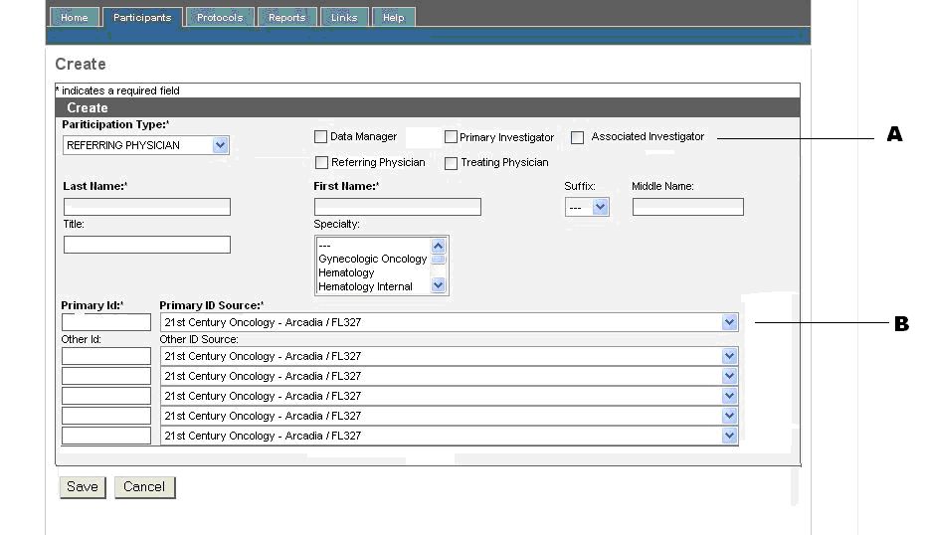

Participant Create Page – Patient
Note: This page was already provided with the previous screen shots and is provided again for reference.
- SSN is moved next to Birth date.
- The Primary ID and Primary ID Source moved at bottom.
- Drop down lists modified.

